JED-I ASSIGNMENT-1 SUBMISSION ---TEAM NUMBER 12

Team Members - Shyamprasad V Atri , Spandana K R , Parikshit B G , Kartik M Kerur

LCR circuit in State Space form

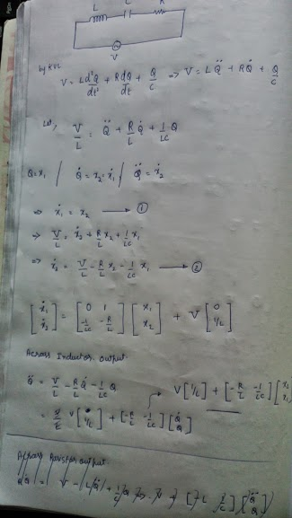

CASE 1

1. Output across inductor when R=0 ohms

function jedi_a1_r0_l

r=0; %ohm

l=1e-3; %henry

c=1e-6; %farads

A=[0 1;-1/(l*c) -r/l];

B=[0;1/l];

C_l=[-r -1/c];

D=0;

sys_lcr_l=ss(A,B,C_l,D);

[eig_vec,eig_val]=eig(A)

step(sys_lcr_l)

end

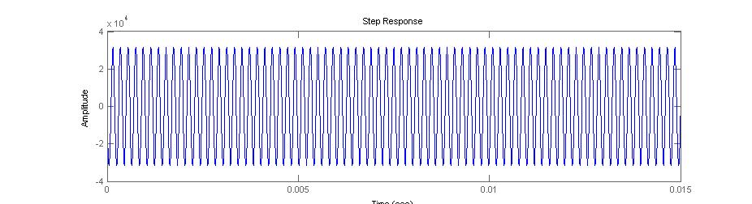

eig_vec =

0 - 0.0000i 0 + 0.0000i

1.0000 1.0000

eig_val =

1.0e+004 *

0 + 3.1623i 0

1. 0 - 3.1623i

b) Output across capacitor when R=0 ohms

function jedi_a1_r0_c

r=0; %ohm

l=1e-3; %henry

c=1e-6; %farads

A=[0 1;-1/(l*c) -r/l];

B=[0;1/l];

C_c=[1/c 0];

D=0;

sys_lcr_c=ss(A,B,C_c,D);

[eig_vec,eig_val]=eig(A)

step(sys_lcr_c)

end

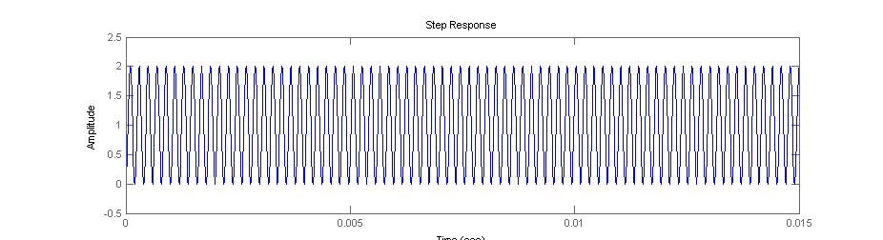

c)Output across resistor when R=0 ohms

function jedi_a1_r0_r

r=0; %ohm

l=1e-3; %henry

c=1e-6; %farads

A=[0 1;-1/(l*c) -r/l];

B=[0;1/l];

C_r=[0 r];

D=0;

sys_lcr_r=ss(A,B,C_r,D);

[eig_vec,eig_val]=eig(A)

step(sys_lcr_r)

end

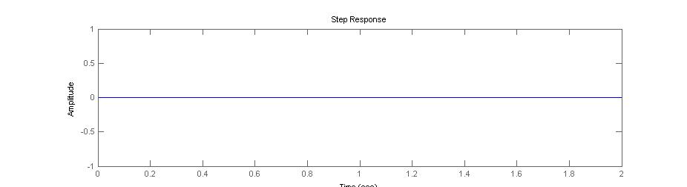

CASE 2

a)Output across inductor when R=1000 ohms

function jedi_a1_r1000_l

r=1000; %ohm

l=1e-3; %henry

c=1e-6; %farads

A=[0 1;-1/(l*c) -r/l];

B=[0;1/l];

C_l=[-r/l -1/(c*l)];

D=0;

sys_lcr_l=ss(A,B,C_l,D);

[eig_vec,eig_val]=eig(A)

step(sys_lcr_l)

end

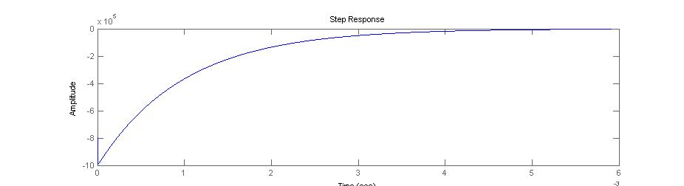

eig_vec =

0.0010 -0.0000

-1.0000 1.0000

eig_val =

1.0e+005 *

-0.0100 0

0 -9.9900

b)Output across capacitor when R=1000

function jedi_a1_r1000_c

r=1000; %ohm

l=1e-3; %henry

c=1e-6; %farads

A=[0 1;-1/(l*c) -r/l];

B=[0;1/l];

C_c=[1/c 0];

D=0;

sys_lcr_c=ss(A,B,C_c,D);

[eig_vec,eig_val]=eig(A)

step(sys_lcr_c)

end

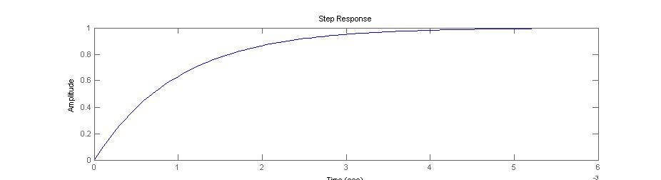

c)Output across resistor when R=1000

function jedi_a1_r1000_r

r=1000; %ohm

l=1e-3; %henry

c=1e-6; %farads

A=[0 1;-1/(l*c) -r/l];

B=[0;1/l];

C_r=[0 r];

D=0;

sys_lcr_r=ss(A,B,C_r,D);

[eig_vec,eig_val]=eig(A)

step(sys_lcr_r)

end

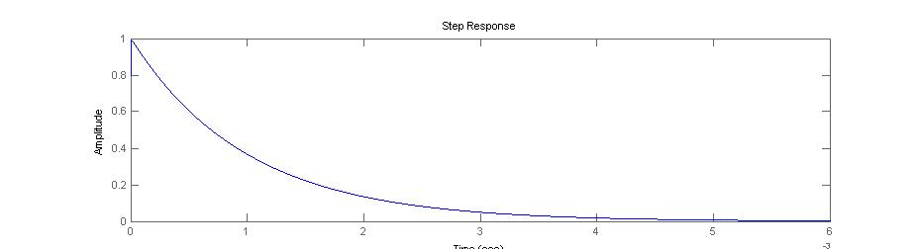

CASE 3

When unit step input is given the D values in Matlab Programme change to 1

i.e D=1

Ana it was observed that al the graphs shift by one unit in y axis

Example is shown for Resistor

function jedi_a1_r1000_u1_r

r=1000; %ohm

l=1e-3; %henry

c=1e-6; %farads

A=[0 1;-1/(l*c) -r/l];

B=[0;1/l];

C_r=[0 r];

d=0;

D=1;

sys_lcr_r=ss(A,B,C_r,D);

sys_lcr_u1_r=ss(A,B,C_r,d)

[eig_vec,eig_val]=eig(A)

step(sys_lcr_u1_r,sys_lcr_r)

end

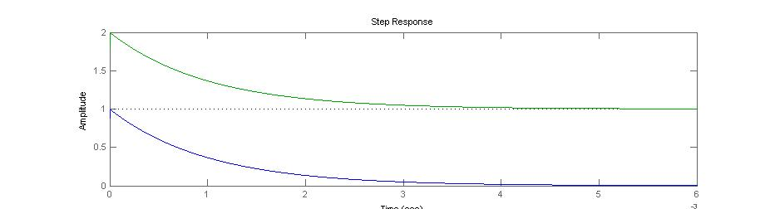

For CASE 2 when R=1000

Oscillatory Response was not got instead Damped response was found

Damping ratio=(alfa/Omega)

Alfa for seres LCR=R/(2*L)

Omega=1/sqrt(L*C)

For CASE 1 since R=0 alfa=0 so no Damping

For CASE 2 Since R=1000

Alfa=1000/(2*(1/1000))

Alfa=500000

Omega=1/sqrt((1/1000)*(1/1000000))

Omega=31623

Damp Ratio=Alfa/Omega

Damp Ratio=500000/31623=15.8113

The Given System is Over Damped because of Highly negative eigen values in the real part of eigen values.

Eigen Values of the system is mentioned above